Ebert Construction Fall Safety Newsletter

Contacts:
Samantha Suchanek: Secretary of Safety Committee: Email-ssuchanek@ebertconst.com
Rob Jurmu: General Job Superintendent/ Safety Advisor: Email-rjurmu@ebertconst.com

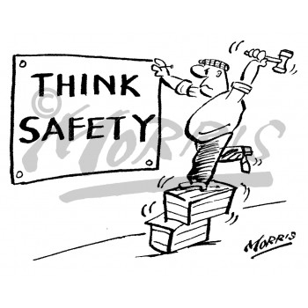
COLD STRESS

Overview
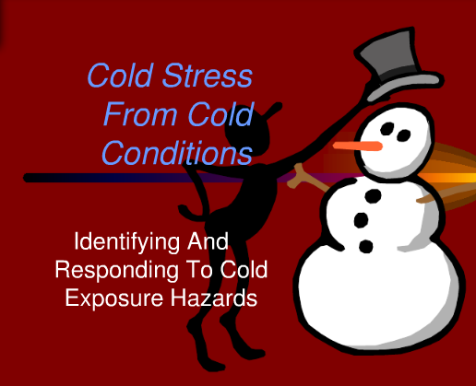
Workers who are exposed to extreme cold or work in cold environments may be at risk of cold stress. Extreme cold weather is a dangerous situation that can bring on health emergencies in susceptible people, such as those without shelter, outdoor workers, and those who work in an area that is poorly insulated or without heat. What constitutes cold stress and its effects can vary across different areas of the country. In regions relatively unaccustomed to winter weather, near freezing temperatures are considered factors for "cold stress." Whenever temperatures drop decidedly below normal and as wind speed increases, heat can more rapidly leave your body. These weather-related conditions may lead to serious health problems.

Types of Cold Stress
Hypothermia | Cold Water Immersion| Frostbite| Trench Foot| Chilblains

Hypothermia
When exposed to cold temperatures, your body begins to lose heat faster than it can be produced. Prolonged exposure to cold will eventually use up your body's stored energy. The result is hypothermia, or abnormally low body temperature. A body temperature that is too low affects the brain, making the victim unable to think clearly or move well. This makes hypothermia particularly dangerous because a person may not know it is happening and will not be able to do anything about it.

Symptoms
Symptoms of hypothermia can vary depending on how long you have been exposed to the cold temperatures.

Early Symptoms
- Shivering
- Fatigue
- Loss of coordination
- Confusion and disorientation

Late Symptoms
- No shivering
- Blue skin
- Dilated pupils
- Slowed pulse and breathing
- Loss of consciousness

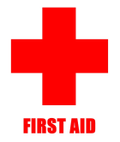
First Aid

Take the following steps to treat a worker with hypothermia:
- Alert the supervisor and request medical assistance.
- Move the victim into a warm room or shelter.
- Remove their wet clothing.
- Warm the center of their body first-chest, neck, head, and groin-using an electric blanket, if available; or use skin-to-skin contact under loose, dry layers of blankets, clothing, towels, or sheets.
- Warm beverages may help increase the body temperature, but do not give alcoholic beverages. Do not try to give beverages to an unconscious person.
- After their body temperature has increased, keep the victim dry and wrapped in a warm blanket, including the head and neck.
- If victim has no pulse, begin cardiopulmonary resuscitation (CPR).

Cold Water Immersion
Cold water immersion creates a specific condition known as immersion hypothermia. It develops much more quickly than standard hypothermia because water conducts heat away from the body 25 times faster than air. Typically people in temperate climates don’t consider themselves at risk from hypothermia in the water, but hypothermia can occur in any water temperature below 70°F. Survival times can be lengthened by wearing proper clothing (wool and synthetics and not cotton), using a personal flotation device (PFD, life vest, immersion suit, dry suit), and having a means of both signaling rescuers (strobe lights, personal locator beacon, whistles, flares, waterproof radio) and having a means of being retrieved from the water. Below you will find links with information about cold water survival and cold water rescue.
- NIOSH Commercial Fishing Safety Topic Page
- Alaska Marine Safety Education Association
- Minnesota Sea Grant
- U.S. Search and Rescue Task Force
- NIOSH Firefighter FACE Program Reports on Drowning

Frostbite
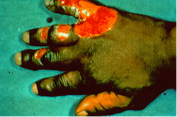
Frostbite is an injury to the body that is caused by freezing. Frostbite causes a loss of feeling and color in the affected areas. It most often affects the nose, ears, cheeks, chin, fingers, or toes. Frostbite can permanently damage body tissues, and severe cases can lead to amputation. In extremely cold temperatures, the risk of frostbite is increased in workers with reduced blood circulation and among workers who are not dressed properly.

Symptoms
Symptoms of frostbite include:
- Reduced blood flow to hands and feet (fingers or toes can freeze)
- Numbness
- Tingling or stinging
- Aching
- Bluish or pail, waxy skin

First Aid

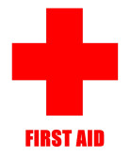
Workers suffering from frostbite should:

- Get into a warm room as soon as possible.
- Unless absolutely necessary, do not walk on frostbitten feet or toes-this increases the damage.
- Immerse the affected area in warm-not hot-water (the temperature should be comfortable to the touch for unaffected parts of the body).
- Warm the affected area using body heat; for example, the heat of an armpit can be used to warm frostbitten fingers.
- Do not rub or massage the frostbitten area; doing so may cause more damage.
- Do not use a heating pad, heat lamp, or the heat of a stove, fireplace, or radiator for warming. Affected areas are numb and can be easily burned.

Trench Foot
Trench foot, also known as immersion foot, is an injury of the feet resulting from prolonged exposure to wet and cold conditions. Trench foot can occur at temperatures as high as 60 degrees F if the feet are constantly wet. Injury occurs because wet feet lose heat 25-times faster than dry feet. Therefore, to prevent heat loss, the body constricts blood vessels to shut down circulation in the feet. Skin tissue begins to die because of lack of oxygen and nutrients and due to the buildup of toxic products.

Symptoms
Symptoms of trench foot include:
- Reddening of the skin
- Numbness
- Leg cramps
- Swelling
- Tingling pain
- Blisters or ulcers
- Bleeding under the skin
- Gangrene (the foot may turn dark purple, blue, or gray)

First Aid

Workers suffering from trench foot should:
- Remove shoes/boots and wet socks.
- Dry their feet.
- Avoid walking on feet, as this may cause tissue damage.

Chilblains
Chilblains are caused by the repeated exposure of skin to temperatures just above freezing to as high as 60 degrees F. The cold exposure causes damage to the capillary beds (groups of small blood vessels) in the skin. This damage is permanent and the redness and itching will return with additional exposure. The redness and itching typically occurs on cheeks, ears, fingers, and toes.

Symptoms
Symptoms of chilblains include:
- Redness
- Itching
- Possible blistering
- Inflammation
- Possible ulceration in severe cases

First Aid

Workers suffering from chilblains should:

- Avoid scratching
- Slowly warm the skin
- Use corticosteroid creams to relieve itching and swelling
- Keep blisters and ulcers clean and covered

Recommendations for Employers
Employers should take the following steps to protect workers from cold stress:
- Schedule maintenance and repair jobs in cold areas for warmer months.
- Schedule cold jobs for the warmer part of the day.
- Reduce the physical demands of workers.
- Use relief workers or assign extra workers for long, demanding jobs.
- Provide warm liquids to workers.
- Provide warm areas for use during break periods.
- Monitor workers who are at risk of cold stress.
- Provide cold stress training that includes information about:
  - Worker risk
  - Prevention
  - Symptoms
  - The importance of monitoring yourself and coworkers for symptoms
  - Treatment
  - Personal protective equipment

Recommendations for Workers
Workers should avoid exposure to extremely cold temperatures when possible. When cold environments or temperatures can not be avoided, workers should follow these recommendations to protect themselves from cold stress:
- Wear appropriate clothing.
  - Wear several layers of loose clothing. Layering provides better insulation.
  - Tight clothing reduces blood circulation. Warm blood needs to be circulated to the extremities.
  - When choosing clothing, be aware that some clothing may restrict movement resulting in a hazardous situation.
- Make sure to protect the ears, face, hands and feet in extremely cold weather.
- Boots should be waterproof and insulated.
- Wear a hat; it will keep your whole body warmer. (Hats reduce the amount of body heat that escapes from your head.)
- Move into warm locations during work breaks; limit the amount of time outside on extremely cold days.
- Carry cold weather gear, such as extra socks, gloves, hats, jacket, blankets, a change of clothes and a thermos of hot liquid.
- Include a thermometer and chemical hot packs in your first aid kit.
- Avoid touching cold metal surfaces with bare skin.
- Monitor your physical condition and that of your coworkers.

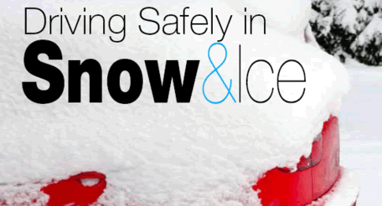
Safe Winter Driving
Winter driving can be hazardous and scary, especially in northern regions that get
a lot of snow and ice. Additional preparations can help make a trip safer, or help
motorists deal with an emergency. This sheet provides safety information to your
residents to help prevent motor vehicle injuries due to winter storms.
The three P’s of Safe Winter Driving:
PREPARE for the trip; PROTECT yourself; and PREVENT crashes on the road.
PREPARE
Maintain Your Car: Check battery, tire tread, and windshield wipers, keep your
windows clear, put no-freeze fluid in the washer reservoir, and check your antifreeze.
Have On Hand: flashlight, jumper cables, abrasive material (sand, kitty litter, even
floor mats), shovel, snow brush and ice scraper, warning devices (like flares) and
blankets. For long trips, add food and water, medication and cell phone.
Stopped or Stalled? Stay in your car, don’t overexert, put bright markers on antenna
or windows and shine dome light, and, if you run your car, clear exhaust pipe and
run it just enough to stay warm.
Plan Your route: Allow plenty of time (check the weather and leave early if
necessary), be familiar with the maps/ directions, and let others know your route
and arrival time.
Practice Cold Weather Driving!
- During the daylight, rehearse maneuvers slowly on ice or snow in an empty lot.
- Steer into a skid.
- Know what your brakes will do: stomp on antilock brakes, pump on non-antilock
- brakes.
- Stopping distances are longer on water-covered ice and ice.
- Don’t idle for a long time with the windows up or in an enclosed space.
PROTECTYOURSELF
- Buckle up and use child safety seats properly.
- Never place a rear-facing infant seat in front of an air bag.
- Children 12 and under are much safer in the back seat.
PREVENT CRASHES
- Drugs and alcohol never mix with driving.
- Slow down and increase distances between cars.
- Keep your eyes open for pedestrians walking in the road.
- Avoid fatigue – Get plenty of rest before the trip, stop at least every three hours,
- and rotate drivers if possible.
- If you are planning to drink, designate a sober driver.
U.S.Department of Labor
www.osha.gov

ELECTRICAL SAFETY – POWER STRIPS
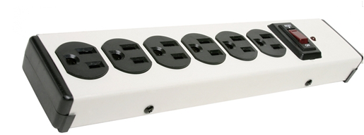
A power strip combines several sockets attached to the end of a flexible cable, allowing multiple devices to be plugged in. The biggest safety concern with power strips is their potential for fire if overloaded.
Precautions for fire prevention:
- Do not plug power strips into other power strips to make what is sometimes called a “piggy back” or “daisy chain.”
- Only use power strips that have a built-in surge protector (i.e., voltage regulator) and preferably also a built-in circuit breaker to prevent circuit overload.
- Do not use power strips for appliances with heating elements, such as electric space heaters or bench-top cooking appliances.
- Assure that all power strips meet recognized testing requirements. Although Underwriters Laboratories (UL) is the most recognizable label, there are many other testing laboratories that test and label electrical equipment.
- Do not plug power strips into extension cords; plug them directly into wall sockets. Extension cords are not to be used for permanent applications.
- A heavy reliance on power strips is an indication that you have too few outlets to address your needs. Have additional outlets professionally installed.
Determining power strip capacity:
Know the capacity of the circuit and the power requirements of all electrical items plugged into the power strip and other outlets on the circuit. In order to determine this:
- Determine the capacity of your power strip (in amps or watts).
- Determine the load (i.e. power requirements) of all the electrical items plugged into the power strip in amps or watts.
- Add up the power requirements. Assure that the total does not exceed 80% of the rated capacity of your power strip. Also, determine the same for the circuit serving the power strip to assure that it is not overloaded.
Example: A power strip is rated for 15 amps/120 V. (Note that watts = amps x volts.)
15 amps x 120 volts = 1875 watts.
1875 watts x 80% = 1500 watts that may be used.
Component | Computer | Monitor | Speakers | Electric Stapler | Scanner | TOTAL
Power Requirement | 250 watts | 150 watts | 15 watts | 25 watts | 150 watts | 590 watts

The power strip’s capacity of 1500 watts is not exceeded.

